**Domain Model**

***Group 3 - Fitness App***

**Member:**

* 1959019 - Phạm Lê Hoàng Minh
* 2159001 - Võ Quang Dũng
* 2159011 - Nguyễn Ngọc Phú

***Table of content***

**Domains Model:**

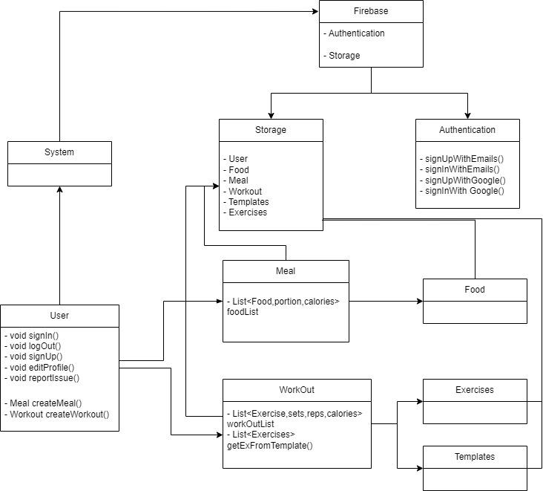

**Description in Sprint 1:**

***User:***

* **UserID:** A unique identifier for each user in the system.
* **FullName:** The full name of the user.
* **Email**: The email address of the user.
* **Password:** The hashed password for user authentication.
* **CreatedTime:** The timestamp when the user account was created.
* **PhoneNumber:** The phone number of the user.
* **Age:** The age of the user.
* **Gender:** The gender of the user.
* **Weight:** The current weight of the user.
* **GoalWeight:** The target weight goal of the user.
* **ImageURL (link to Firebase Storage for profile image):** The URL link to the user's profile image stored in Firebase.

***Profile:***

* **ProfileID:** A unique identifier for each user profile.
* **UserID:** The foreign key linking the profile to the user.
* **Avatar:** The URL link to the user's avatar image.
* **PersonalInformation** *(structured JSON including phone number, age, gender, weight, goal weight)***:** Structured information containing personal details of the user.

***Authentication:***

* **AuthID:** A unique identifier for each authentication entry.
* **UserID:** The foreign key linking the authentication to the user.
* **Email:** The email address associated with the authentication.
* **PasswordHash:** The hashed password for authentication.
* **Sign Up:** Creates a new authentication entry for the user with the provided email and hashed password.
* **Sign In:** Validates the user's email and password for authentication.

***Firebase Storage:***

* **StorageID:** A unique identifier for each storage entry.
* **FileURL:** The URL link to the stored file.
* **FileType:** The type of file stored (e.g., image, document).
* **AccessControl:** Permissions for accessing the stored file.